**GoogleChart Lab**

From: How to use Google Charts API with 6 examples (http://psychopyko.com/tutorial/how-to-use-google-charts/)

Question 1: Pie Chart (change the green color to yellow)

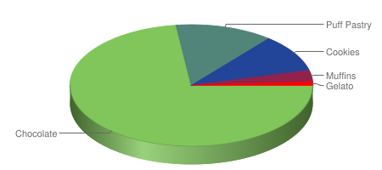

http://chart.apis.google.com/chart?

cht=p3&chs=450x200&chd=t:73,13,10,3,1&

chco=80C65A,224499,FF0000&

chl=Chocolate|Puff+Pastry|Cookies|Muffins|Gelato

Question 2: Horizontal Bar Chart (change the Python’s value to 130. What happen?)

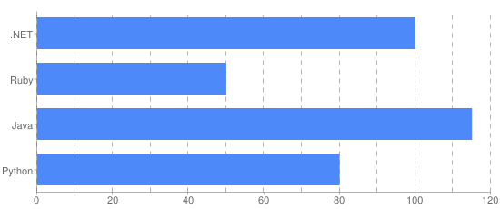

http://chart.apis.google.com/chart?

cht=bhg&chs=550x230&chd=t:100,50,115,80&

chxt=x,y&chxl=1:|Python|Java|Ruby|.NET&

chxr=0,0,120&chds=0,120&

chco=4D89F9&

chbh=35,0,15&

chg=8.33,0,5,5

Question 3: Stacked Vertical Bar Chart (change the encoding scheme to SIMPLE)

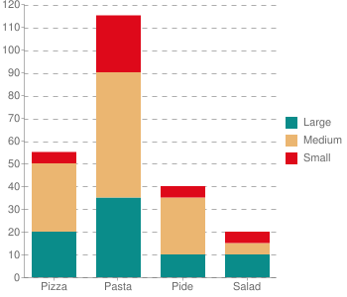

http://chart.apis.google.com/chart?

cht=bvs&chs=350x300&chd=t:20,35,10,5|30,55,25,0|5,25,5,5&

chxr=1,0,120&chds=0,120&

chco=0A8C8A,EBB671,DE091A&

chbh=45,20,15&

chxt=x,y&chxl=0:|Pizza|Pasta|Pide|Salad&

chdl=Large|Medium|Small&

chg=0,8.3,5,5

Question 4: Vertical Bar Chart (re-arrange the bars as follows)

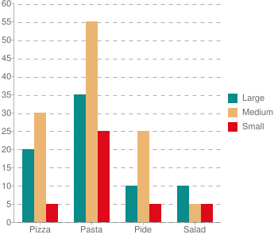

Question 5. (Try to add 2 more rows and a new column)

<html> <head>

<script type="text/javascript" src="https://www.google.com/jsapi"></script>

<script type="text/javascript">

google.load("visualization", "1.1", {packages:["bar"]});

google.setOnLoadCallback(drawChart);

function drawChart() {

var data = google.visualization.arrayToDataTable([

['Year', 'Sales', 'Expenses', 'Profit'],

['2014', 1000, 400, 200],

['2015', 1170, 460, 250],

['2016', 660, 1120, 300],

['2017', 1030, 540, 350]

]);

var options = {

chart: { title: 'Company Performance',

subtitle: 'Sales, Expenses, and Profit: 2014-2017',

},

bars: 'horizontal' // Required for Material Bar Charts.

};

var chart = new google.charts.Bar(document.getElementById('barchart_material'));

chart.draw(data, options);

}

</script> </head>

<body>

<div id="barchart_material" style="width: 900px; height: 500px;"></div>

</body> </html>